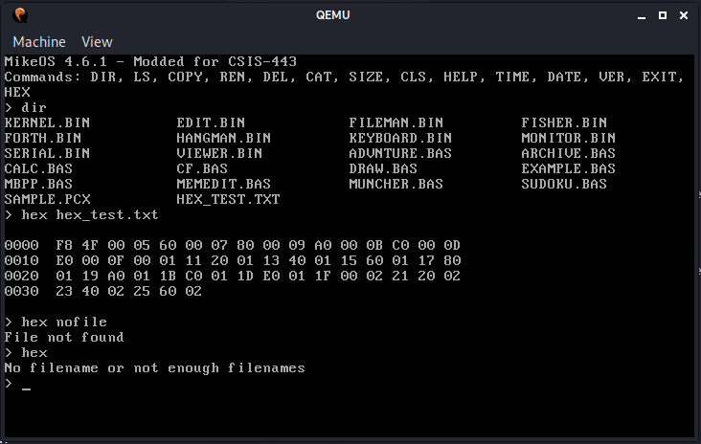

1. Successful run printing all lines before waiting for user input

2. File does not exist

3. No path provided